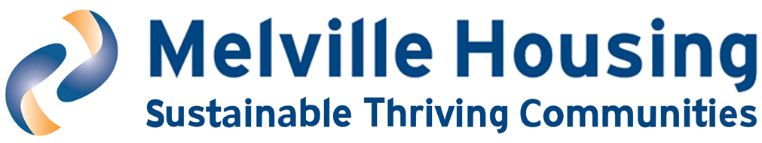

EQUAL OPPORTUNITIES MONITORING FORM

We collect this information for statistical purposes only. Whether or not you complete this form will have no bearing on selection for interview.

In each section, please mark one box with an ‘x’. If none of the options apply, or you would rather not answer a specific question, please leave blank.

AGE
16-24 |  |  | 25 -29 |  |  | 30-34 |  |  | 35-39
40-44 |  |  | 45-49 |  |  | 50-54 |  |  | 55-59
60-65 |  |  | 65+ |  |  | Rather not say
GENDER
Male |  |  | Intersex
Female |  |  | Rather not say

Please let us know if you have any specific requirements
Do you consider yourself to be a trans person?
Yes |  |  | No |  |  | Rather not say
DISABILITY
Do you consider that you have a disability?
Yes |  |  | No |  |  | Rather not say

Autoimmune (eg MS, HIV, Crohn’s)
Learning difficulties (eg Down’s Syndrome)
Mental health issues (eg depression)
Neuro-divergent condition
Physical impairments
Sensory impairment (hearing or visual)

Other (please specify)
MARITAL OR CIVIL PARTNERSHIP STATUS
Are you presently:
Married |  |  | In a registered civil partnership
Neither |  |  | Rather not say
PREGNANCY AND MATERNITY
 | Yes |  | No
Are you pregnant?
Have you taken maternity/paternity leave in the past year?
Prefer not to say
SEXUAL ORIENTATION
Bisexual |  |  | Homosexual (Gay/Lesbian)
Heterosexual |  |  | Rather not say

Other (please specify)
ETHNIC GROUP
Asian |  |  | African
Bangladeshi, Bangladeshi Scottish or Bangladeshi British |  |  | African, African Scottish or African British
Chinese, Chinese Scottish or Chinese British
Indian, Indian Scottish or Indian British
Pakistani, Pakistani Scottish or Pakistani British

Other Asian background |  |  | Other African background

Black or Caribbean
Caribbean, Caribbean Scottish or Caribbean British
Black, Black Scottish or Black British

Other Caribbean or Black background

White
Scottish |  |  | Northern Irish |  |  | Roma
English |  |  | Irish |  |  | Gypsy Traveller
Welsh |  |  | Polish
Mixed group
Mixed/multiple ethnic group

Any other ethnic group
RELIGION OR BELIEF
Buddhist |  |  | Catholic |  |  | Protestant
Other Christian |  |  | Hindu |  |  | Jewish
Muslim |  |  | Sikh |  |  | Atheist/agnostic
Rather not say

Other (please specify)
SPECIAL REQUIREMENTS
Please let us know if you have any special requirements due to any of the above characteristics

